Create And Configure IBM Cloud Service Create A Database in Cloudant DB

|  |  |
| --- | --- |
| **Date** | **29 October 2022** |
| **Team ID** | PNT2022TMID40585 |
| **Project Name** | **loT Based Safety Gadget For Child Safety Monitoring & Notification** |
| **Maximum Marks** | **4 Marks** |

# AIM

To create a database in Cloudant DB to store location data

# STEPS

1. Login to IBM Cloud with smart internz mail ID and Password.

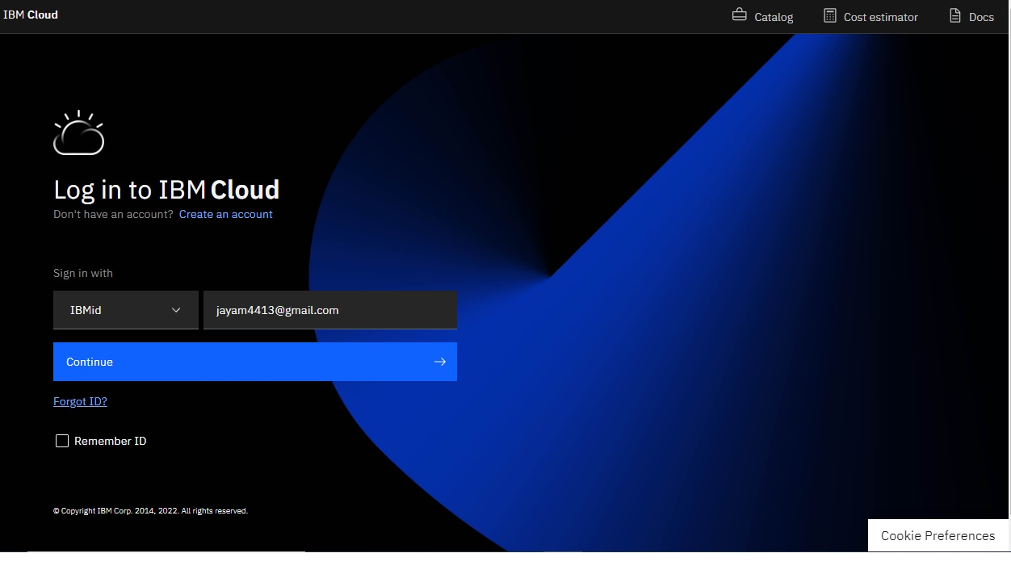

1. 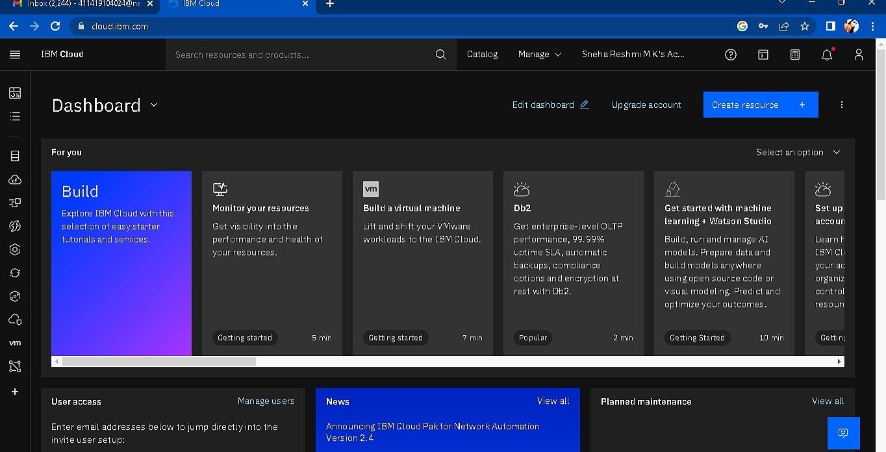Click “Create Resource +” button
2. 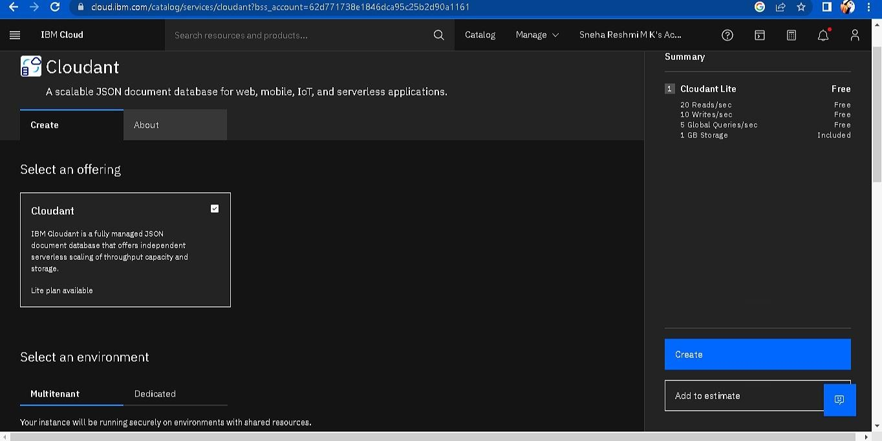Search Cloudant in Catalog then Choose the Lite version

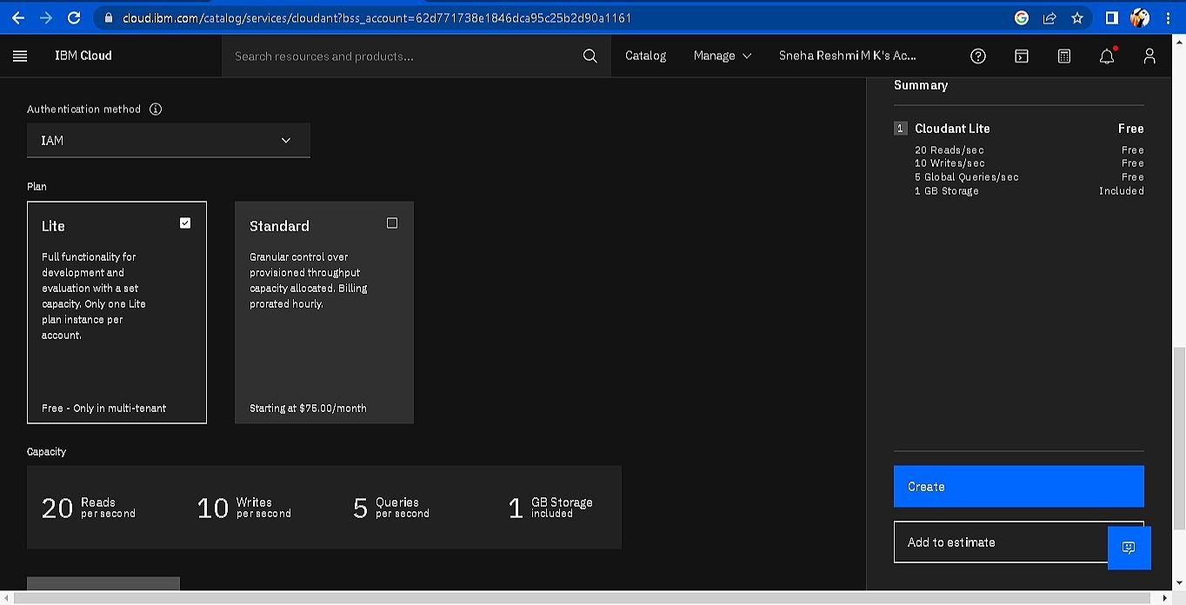

1. 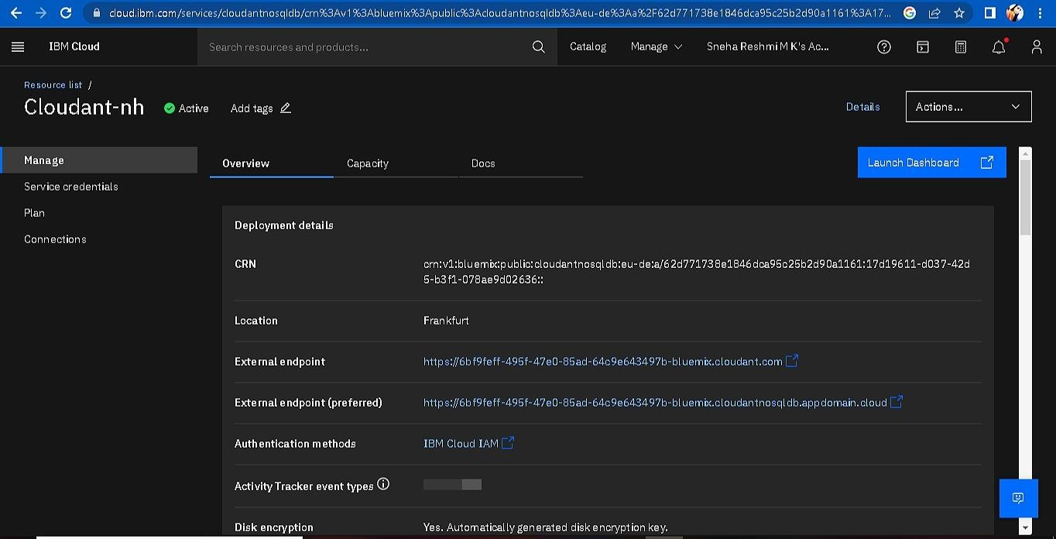The Cloudant database resource created
2. click on launch dashboard

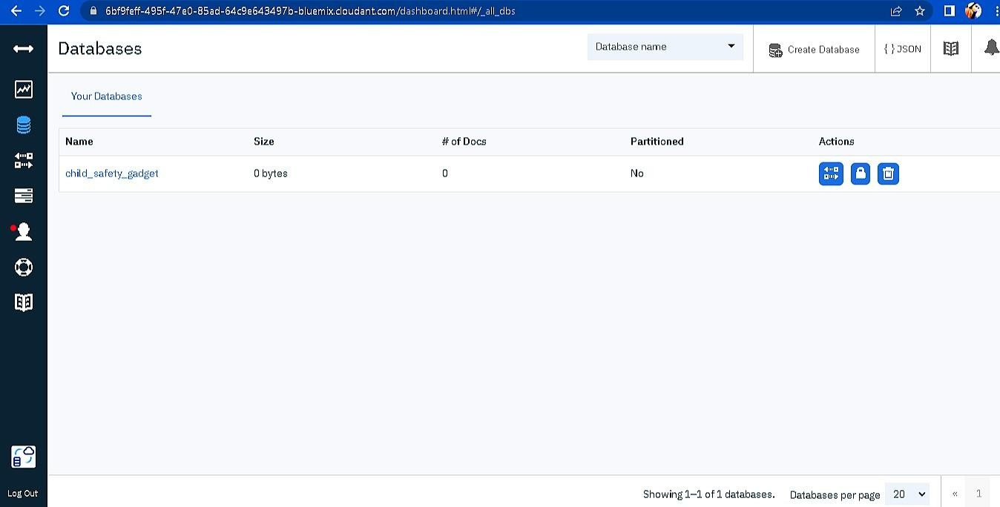

1. Click “Create Database”. Entered “child_safety_device” as the database name and the “Non-partitioned” option.
2. The database “child_safety_device” has been created and it's work Successfully

# RESULT:

A database to store the location data on Cloudant DataBase has been created successfully.

**TEAM ID : PNT2022TMID40585**

**TEAM LEADER 1 : FATHIMA.H**

**TEAM MEMBER 2 : MOHAMMEDASHAFI.J**

**TEAM MEMBER 3 : JEGATHEESHWARAN.T**

**TEAM MEMBER 4 : SYEDABDULLA.J**

**TEAM SIZE : 4**

**MENTOR : Arularumugam**